**DAILY ONLINE ACTIVITIES SUMMARY**

|  |  |  |  |  |  |  |  |  |
| --- | --- | --- | --- | --- | --- | --- | --- | --- |
| **Date:** | **06-06-2020** | | | | | **Name:** | **Nihal Rafiq** | |
| **Sem & Sec** | **4th A** | | | | | **USN:** | **4AL18CS052** | |
| **Online Test Summary** | | | | | | | | |
| **Subject** | | **Data Communication** | | | | | | |
| **Max. Marks** | | **30** | | **Score** | | | **27** | |
| **Certification Course Summary** | | | | | | | | |
| **Course** | **1. Python for Machine learning** | | | | | | | |
| **Certificate Provider** | | | **Great Learning Academy** | | **Duration** | | | **5 hours** |
| **Coding Challenges** | | | | | | | | |
| **Problem Statement:**  **1. Write a java program to find second highest number in array**  **2. Write a C program to rotate an array by N positions** | | | | | | | | |
| **Status: Executed** | | | | | | | | |
| **Uploaded the report in Github** | | | | | **Yes** | | | |
| **If yes Repository name** | | | | | **https://github.com/nihal-art/lockdown-coding** | | | |
| **Uploaded the report in slack** | | | | | **Yes** | | | |

Online Test Details:

Today’s online test was on 5th module of data communication (18CS46). The duration of the test was 40 minute from 9.30 to 10.15am. 30 MCQ. Score I received is 27/30

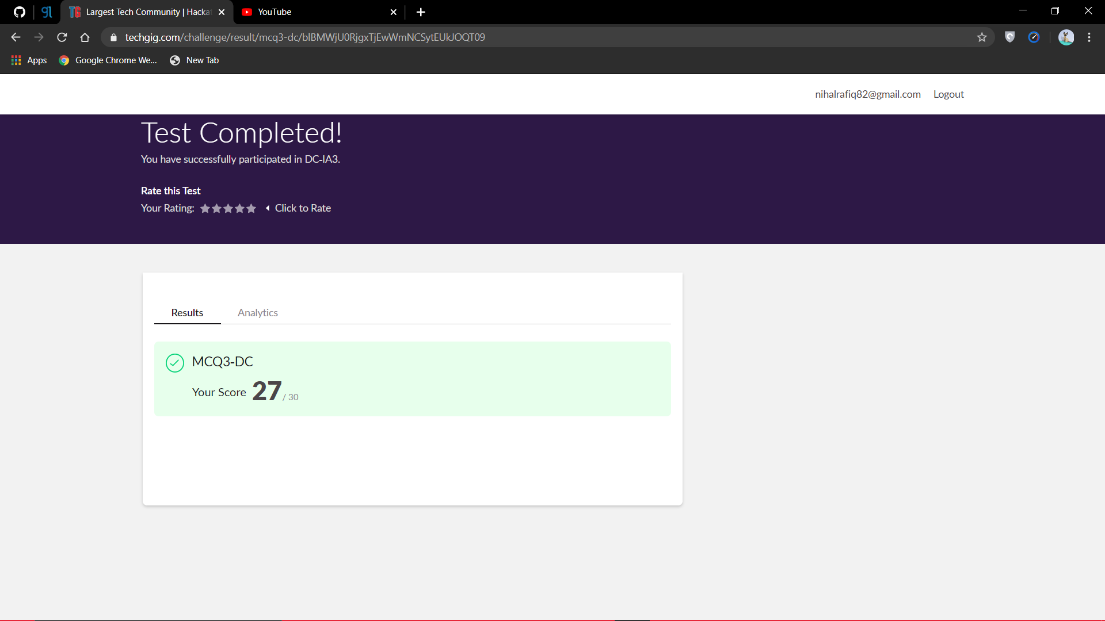

Certification Course Details:

Python for Machine Learning:

Python offers concise and readable code. While complex algorithms and versatile workflows stand behind machine learning and AI, Python’s simplicity allows developers to write reliable systems. Developers get to put all their effort into solving an ML problem instead of focusing on the technical nuances of the languages.

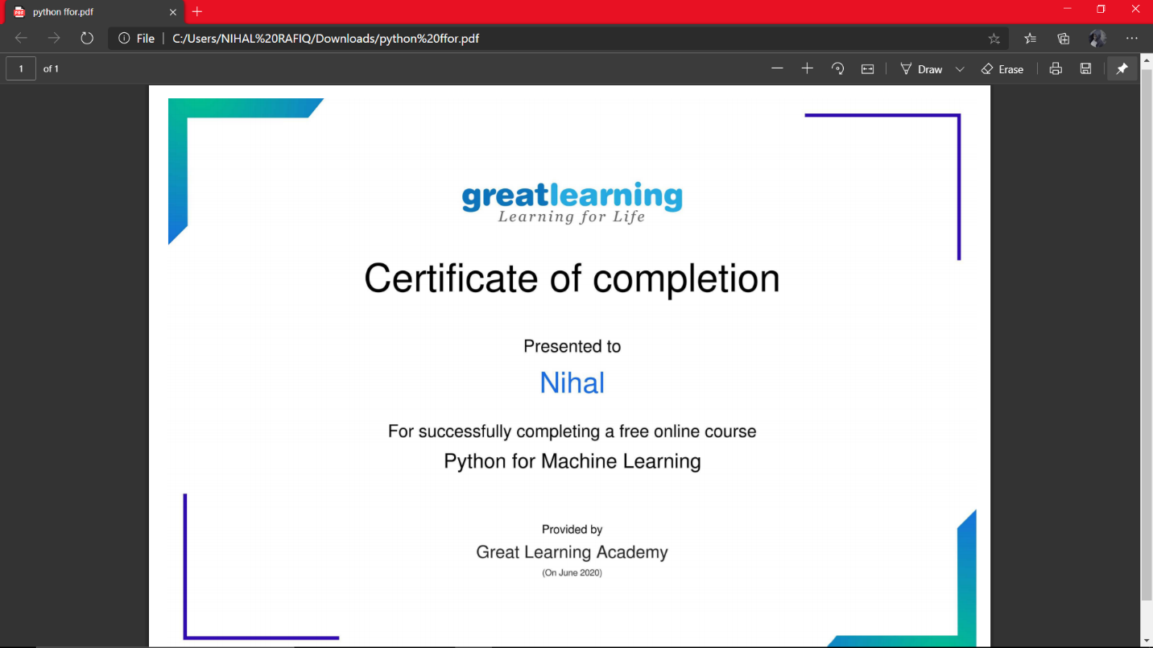

Coding Challenges Details:

1. Write a java program to find second highest number in array

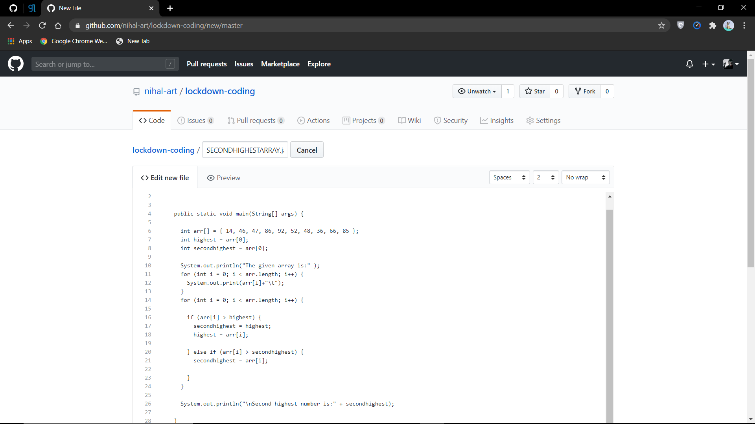

2. Write a C program to rotate an array by N positions

